Task 3: APIs & Integration Decisions
CivicConnect Integration Problem:
How should the CivicConnect user interface communicate with the backend application/service that manages service requests?
This is a genuine integration decision because the UI needs to:
- Submit requests
- View requests
- Update status
- Assign request
- View reports
while the backend needs to:
- Validate
- Authorise
- Apply business rules
- Persist data
- Return results
Producer, Consumer and Information Flow
Element | CivicConnect relation
Caller / Producer | CivicConnect web client/UI
Consumer / Callee | Backend/application service
Information exchanged | Authentication information, request details, request status, categories, assignment data, results/errors
Typical operations | Create request, retrieve request, update status, assign request
Failure consequences | Request submission failure, stale UI information, duplicated operations, unavailable service, incorrect user feedback
Security boundary | The boundary between client and server
Change concern | UI and backend may evolve independently

Integration Alternative 1 — In-process interface
An in-process interface means two components communicate directly inside the same application/runtime.
Conceptually:
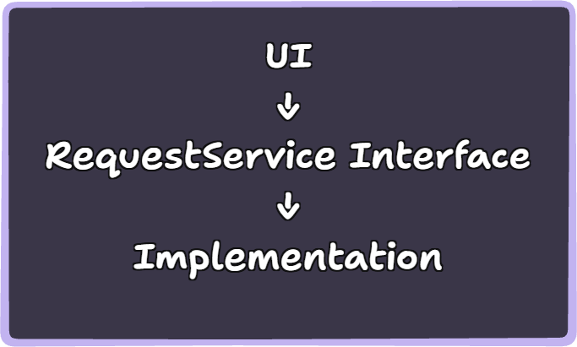
Advantages
- Very low communication overhead.
- No network failure.
- Easy debugging.
- Simple testing.
- Simple deployment.
- Suitable when components genuinely run together.
Disadvantages
The components are deployed together.
They cannot independently scale or deploy.
If the architecture later separates them, the interface may need substantial redesign.
When appropriate
This approach is appropriate when the CivicConnect solution is actually a single deployable application or when the boundary does not justify a network interface.

Integration Alternative 2 — HTTP/REST API
The second option is a REST-style HTTP API.
Conceptually:
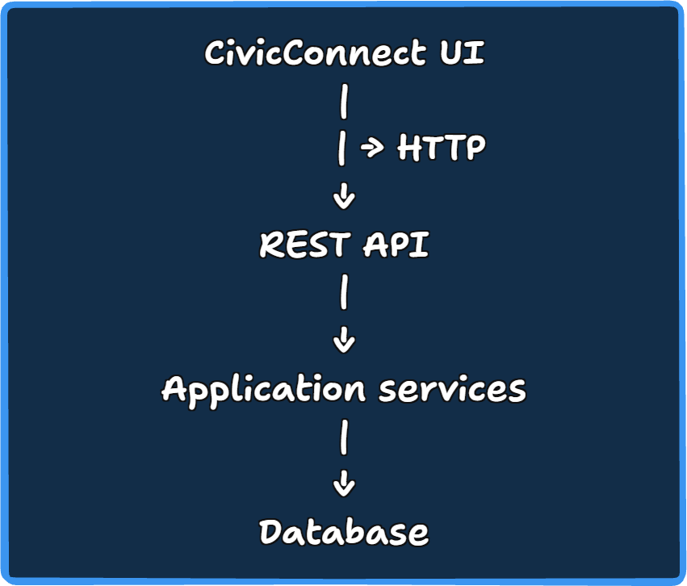

HTTP itself uses a request/response model with defined methods and status codes. RFC 9110 defines HTTP as stateless and describes request methods and response status codes as part of its standard semantics (R. Fielding, 2022).
REST's architectural style was developed by Roy Fielding and emphasises scalability, generality of interfaces and independent deployment of components (Fielding, 2000).
Microsoft's API guidance similarly describes RESTful APIs as providing a stateless, loosely coupled interface between clients and services, with HTTP methods used around resources (Microsoft, 2026).

REST Advantages for CivicConnect
Loose coupling
The frontend does not need to know how the backend implements request processing or persistence.
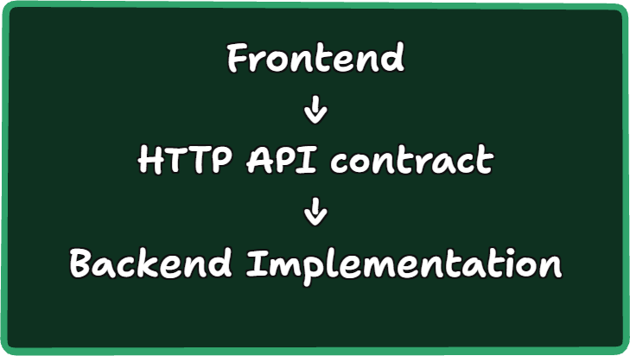
That supports independent evolution of the two sides. Microsoft explicitly identifies loose coupling and platform independence as benefits of RESTful web API design (Microsoft, 2026).
Clear operation semantics
CivicConnect maps relatively naturally onto resources:
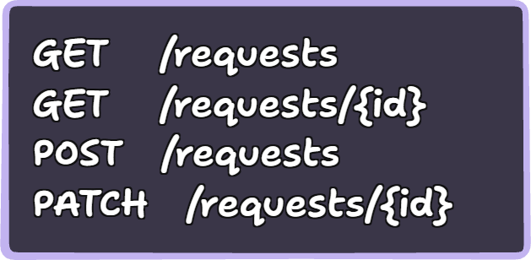
HTTP defines standard request methods and status codes for communicating outcomes (R. Fielding, 2022).
Independent deployment
The client and service can potentially be deployed independently.
This aligns with REST's architectural emphasis on independent component deployment (Fielding, 2000).

REST disadvantages
The network boundary introduces additional failure modes:
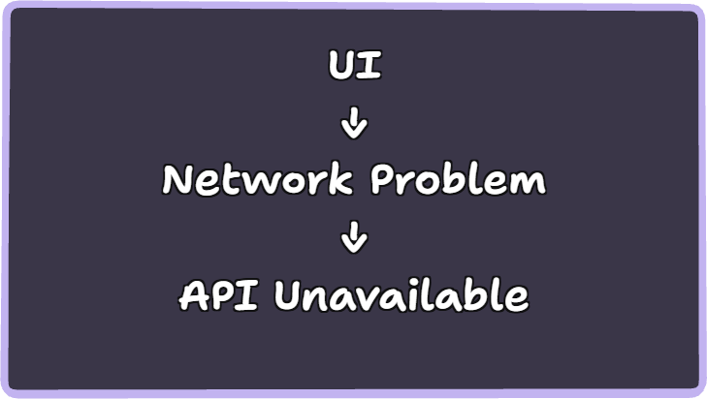
You also introduce:
- network latency;
- authentication/security concerns;
- API version compatibility;
- error handling;
- endpoint contracts;
- deployment configuration.
Microsoft's guidance specifically discusses API versioning because changes to APIs can affect client applications consuming them (Microsoft, 2026).
Security is also a major consideration. OWASP identifies broken object-level authorisation as a major API security risk and recommends authorisation checks for functions that access objects based on identifiers supplied by clients (OWASP API Security Project team, 2023).
That has direct relevance to CivicConnect because a requester must not be able to simply change a request ID and access another user's service request.

Alternative 3 — Asynchronous messaging
The architecture could use:
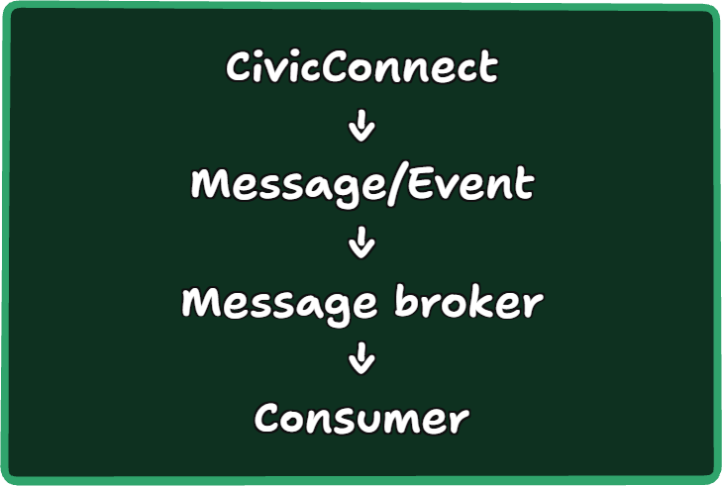
Microsoft describes asynchronous messaging as a model where the sender does not expect an immediate response and notes its usefulness for event-driven communication and eventual consistency.
Benefits
- Loose temporal coupling.
- Consumers don't need to be available at the same time.
- Multiple consumers can subscribe to events.
- Useful for background processing.
Costs
- Much greater infrastructure complexity.
- Message failure/retry handling.
- Event ordering concerns.
- Eventual consistency.
- More difficult debugging.
- Additional deployment infrastructure.
For a relatively small CivicConnect educational project, this could easily become over-engineering unless you have a genuine asynchronous business requirement.

Task 3 Comparison Table:
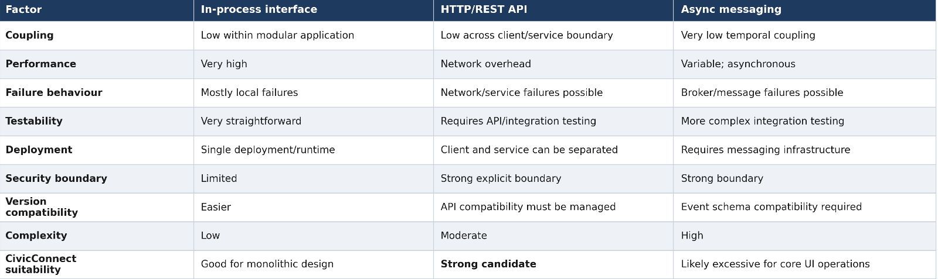

Task 3 Recommendation
Recommended mechanism: HTTP/REST for client ↔ backend communication
For the core CivicConnect interaction between the user interface and backend service, HTTP/REST is the most proportionate choice, considering our team is likely to build separate frontend and backend components.
The reasons are:
- CivicConnect requires many request/response interactions.
- The UI normally needs an immediate result after submitting, retrieving or updating a request.
- HTTP provides standard request methods and response status semantics.
- REST supports a relatively clear separation between client and server.
- The approach provides a clear security boundary.
- It avoids the infrastructure complexity of asynchronous messaging for operations that generally require immediate feedback.
However, this recommendation does not mean every internal CivicConnect interaction should use HTTP.
For example:
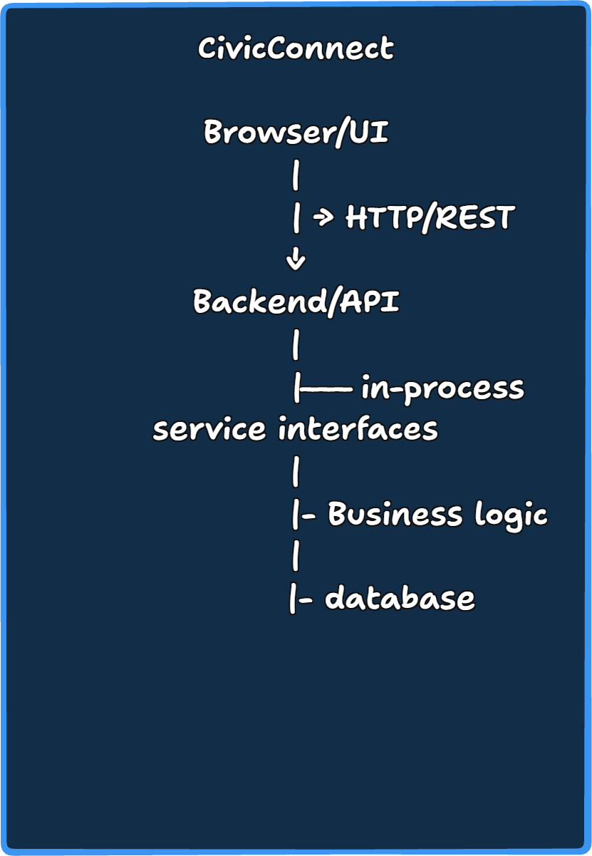

Task 3 feeding into Milestone 2:
